Finding your geo classes

When you open ArcGIS, go under project and databases

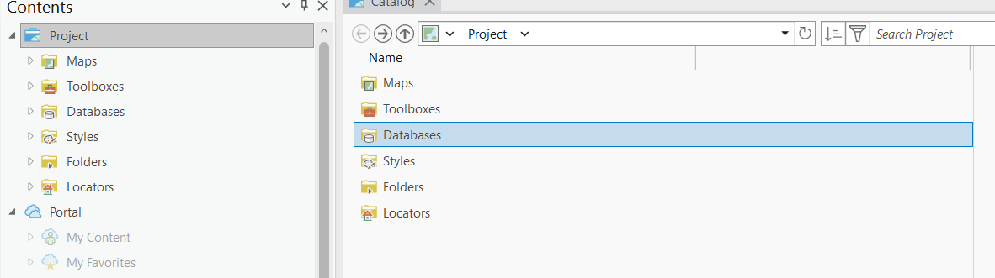

Avon_park

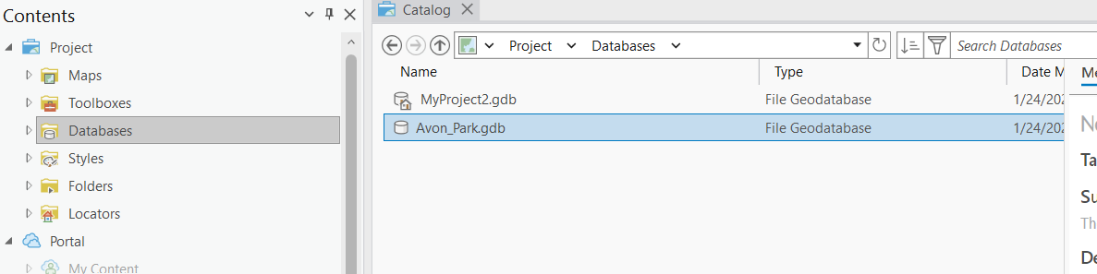

Links are found under Model. Under Model_Param, you’ll find Pipe_Param and DS_Param. I believe these are the two tables Aylssa mentioned we’d need to build the Pipe csv for ICPR. I will try to confirm this with her, but work with these two in the meantime.

